ORPCA Webmaster Report
April 2020
4/8/2020

Website Visitors

- 533 visitor per day in the last 30 days (618 last month)
- 16,539 total visitors in the last 30 days (18,530 last month)
- Tendency: 15% drop (surprisingly small drop given the COVID-19 situation)

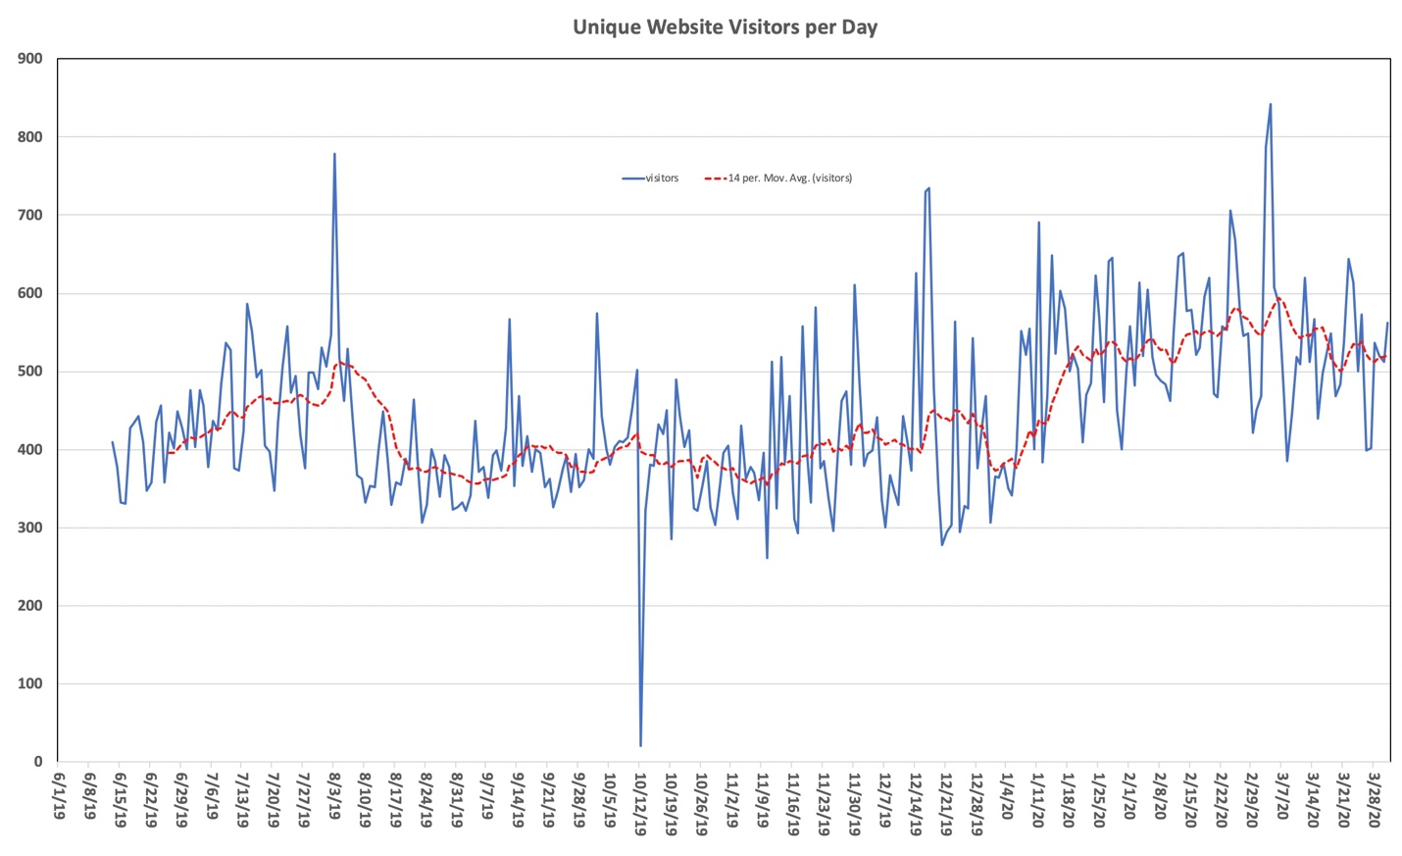

Website Issues: One issue in the last 30 days
- Website maintenance:
  - copied live to staging site for synchronization
  - did not turn of email client on staging site after transfer
  - staging site sent membership dues emails to members in parallel to live site leading to confusion as some members had already paid
  - turned off the email client on stage site, transferred all orders that where wrongly taken on the staging site to the life site
Website Performance

Stripe
- In March 2020 we had a total of 40 members using the online payment through Stripe.
  - 31 of which were member renewals and 9 new members.
- Refunds increased significantly (5 NW passage, 12 March and April Social)

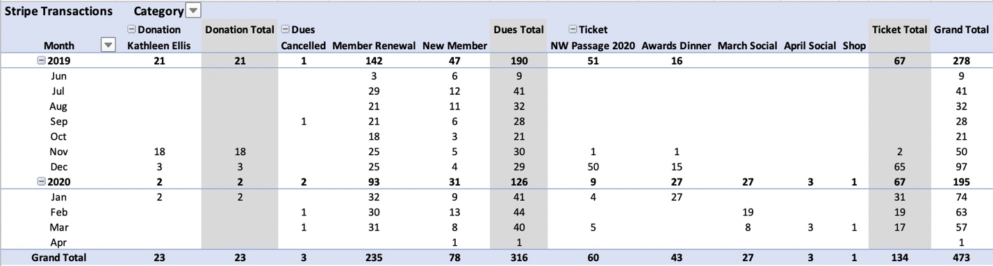

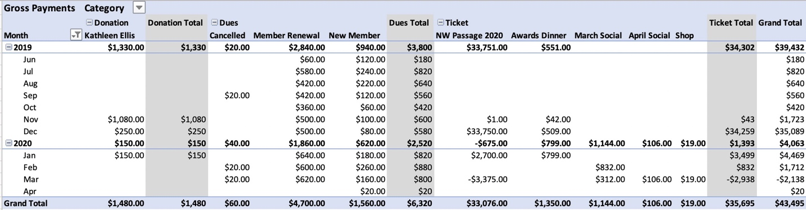

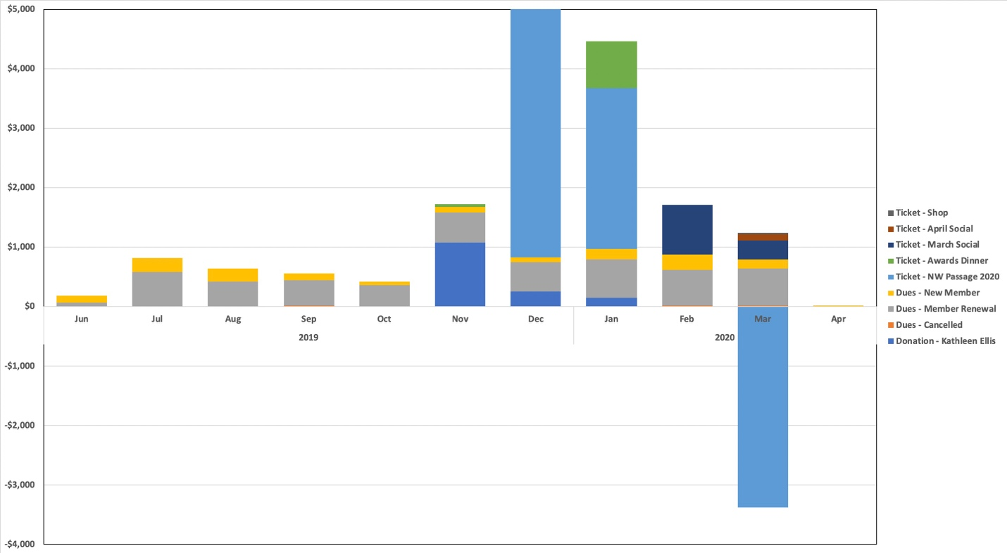
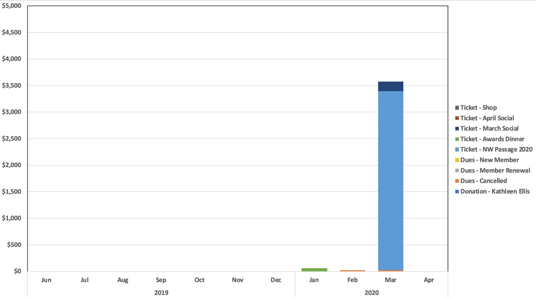

Website Maintenance and Upgrades - Update

Oyova work items for improvements on web page infrastructure:

Extending Reports
- Shortening monthly report generation
- Oyova effort: 3-4 hours
Moving child theme to plugin
- Improved upgrade stability of web page
- Oyova ffort: 1 hour
Duplicating fields into ACF
- Eliminating dominant error source for membership database
- Oyova Effort: 3-5 hours
Extending Checkout
- Making PCA number a must have for new online sign-ups’
- Oyova Effort: 2-3 hours

Total Effort 9-13 hours, Total Cost $990 - $1430

$1430 budget for Oyova work was approved last board meeting. I held back asking Oyova for the work in light of the worsening COVID-19 impacts to club activities. Should we postpone this work until we have a better understanding of our yearly financials?

